**Amazon redshift**

**Amazon Redshift** is a fully managed data warehouse service in the Amazon Web Services (AWS) cloud. It is designed to handle large-scale data analytics and business intelligence tasks by enabling users to run complex queries and perform data analysis on vast amounts of data quickly and efficiently.

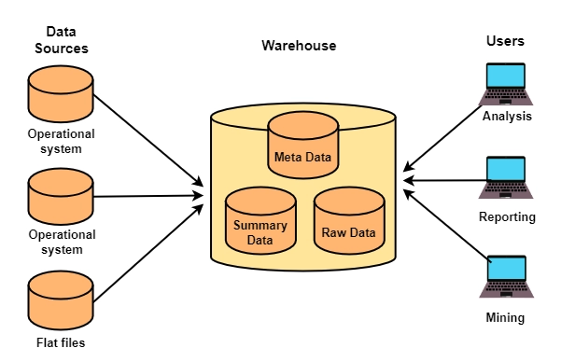

**Features :**

**Scalability:** Redshift can scale from a single 160GB node to a petabyte(1000tb=1000000gb) or more of storage by adding nodes to your cluster.

**Performance:** It also employs massively parallel processing (MPP), which means it can distribute data and query loads across multiple nodes, making it extremely fast.

**Security:** Redshift provides robust security features including network isolation using Amazon Virtual Private Cloud (VPC), encryption at rest and in transit, and integration with AWS Identity and Access Management (IAM) for access control.

**Difference between Data Lake , Data Base and Data WareHouse :**

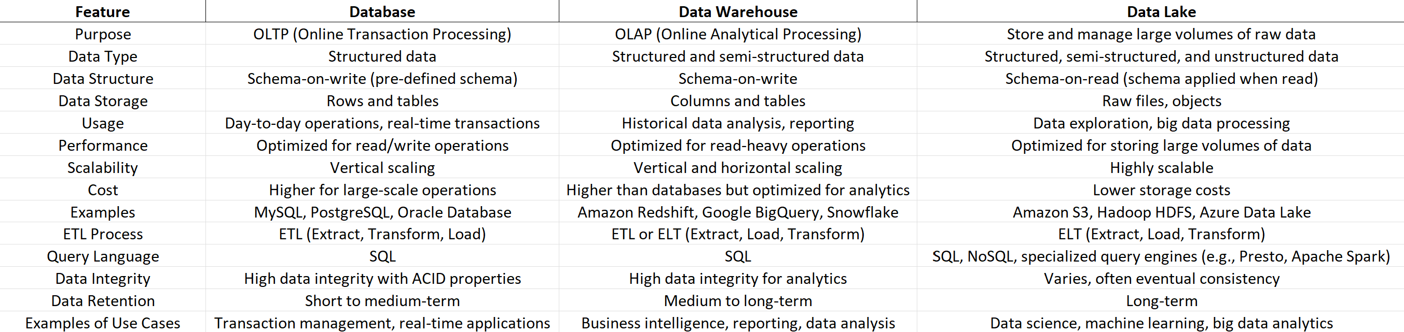

**Flow Chart :**

